EXPT NO:2 | LOAD AND VISUALIZE A DATASET USING TABLEAU and PowerBI
DATE: 10.07.2026

PRE-LAB QUESTIONS (PROVIDE BRIEF ANSWERS TO THE FOLLOWING QUESTIONS)
- Why is Tableau a preferred tool for data visualization?
Tableau is preferred because it allows users to create interactive and visually appealing charts and dashboards with minimal coding. It supports multiple data sources and provides easy drag-and-drop functionality.

- What is the primary use of a line chart in data analysis?
A line chart is primarily used to show trends and changes in data over time, such as monthly or yearly sales.

- When would you use a tree map instead of a bar chart?
A tree map is useful when displaying hierarchical data and comparing the relative contribution of many categories or sub-categories using size and color.

- What is the significance of filters in Tableau visualizations?
Filters allow users to view specific subsets of data, such as a particular year, region, or category. They make visualizations interactive and support focused analysis.

- How does Tableau handle geographic data for visualizations?
Tableau automatically recognizes geographic fields such as countries, states, and cities and assigns geographic roles. It can then plot the data on maps using latitude and longitude.

IN-LAB EXERCISE:
OBJECTIVE:
To load a dataset into Tableau, create a variety of visualizations, and derive insights from the data using different chart types available in Tableau.

PROCEDURE:

Dataset Selection:
Use the Global Superstore Sales Dataset (available on Kaggle or Tableau's sample datasets).
Ensure the dataset includes fields like Order Date, Category, Region, Sales, Profit, and Customer Segment.

Data Loading:
Open Tableau and connect to the dataset.
Review the dataset structure, field data types, and missing values.
Chart Creations (Step-by-Step):
- Bar Chart:
Objective: Compare total sales by region and category.
Plot Region on the x-axis and Sales on the y-axis. Add Category as a color dimension.
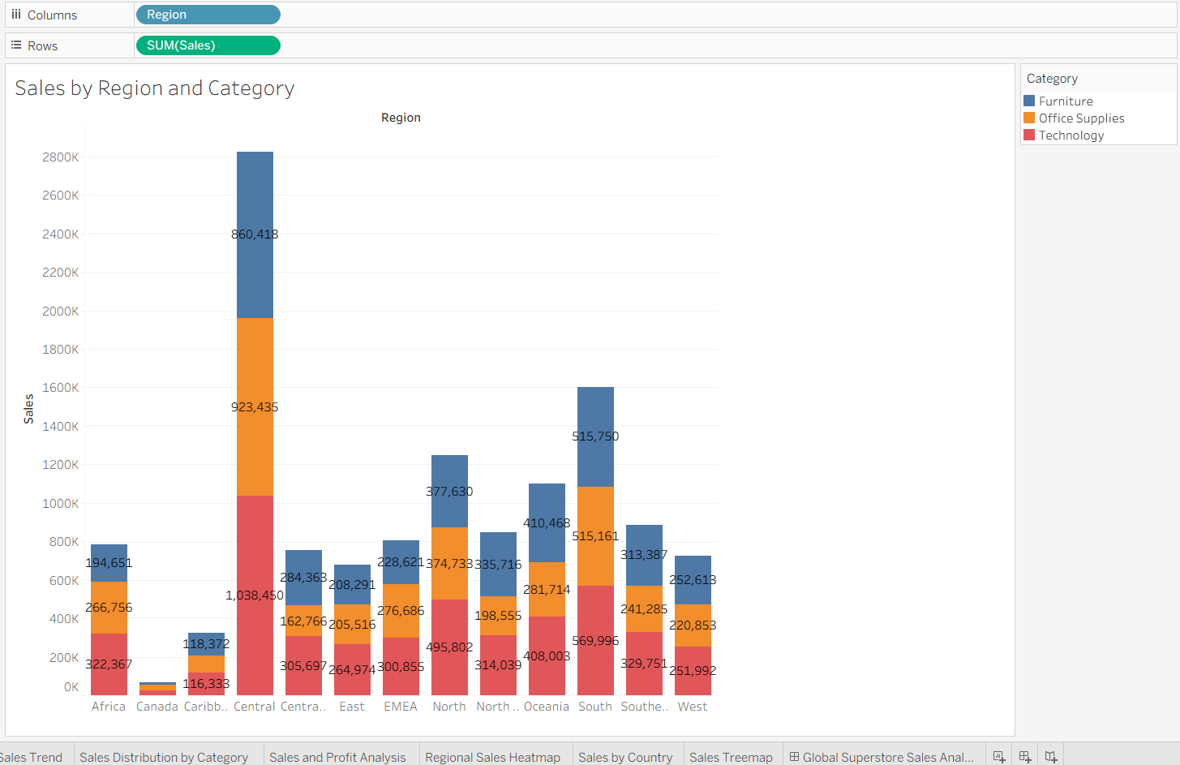

Line Chart:
Objective: Visualize sales trends over time.
Place Order Date on the x-axis and Sales on the y-axis. Set granularity to Month and color by Category.
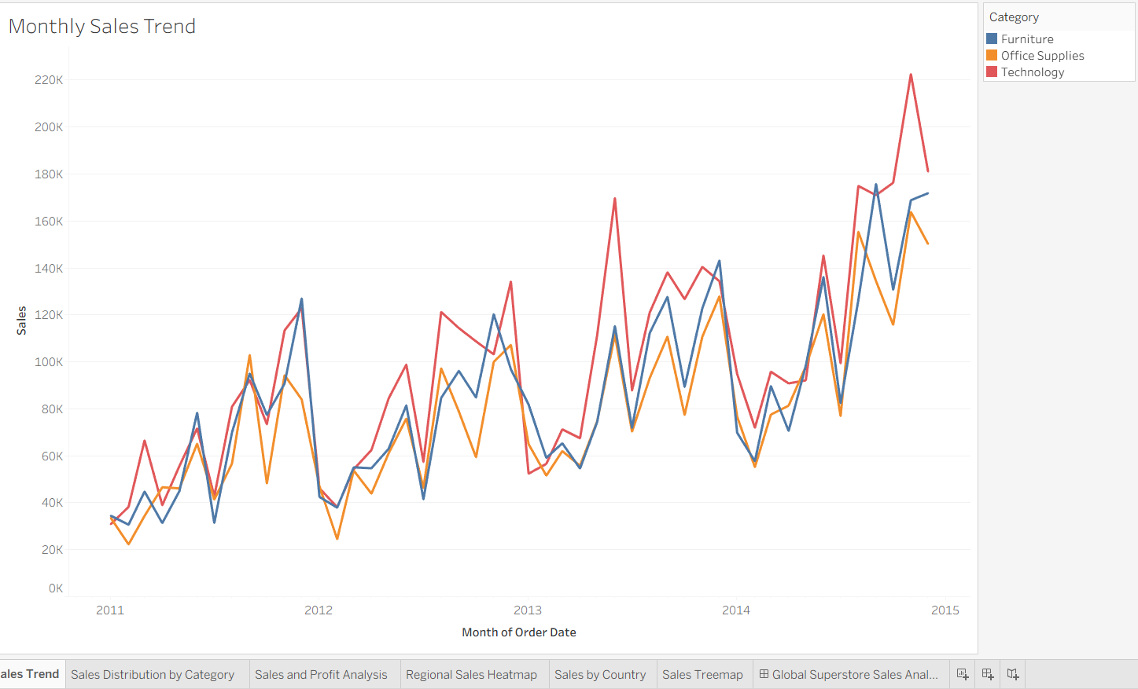

Pie Chart:
Objective: Show sales distribution by product category.
Assign Category as the dimension and Sales as the measure.
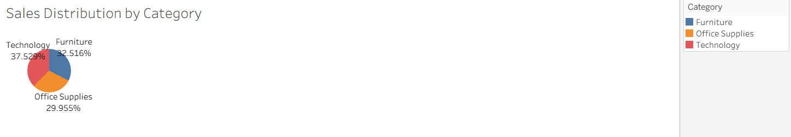

Scatter Plot:
Objective: Examine the relationship between profit and sales.
Plot Profit on the x-axis and Sales on the y-axis.

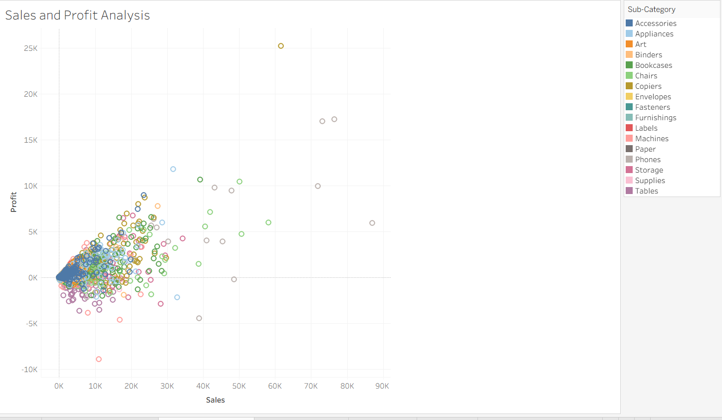
Use Sub-Category as the color dimension.

Heatmap:
Objective: Compare sales across categories and regions.
Use Region and Category as dimensions.
Use Sales as the measure and apply color coding.
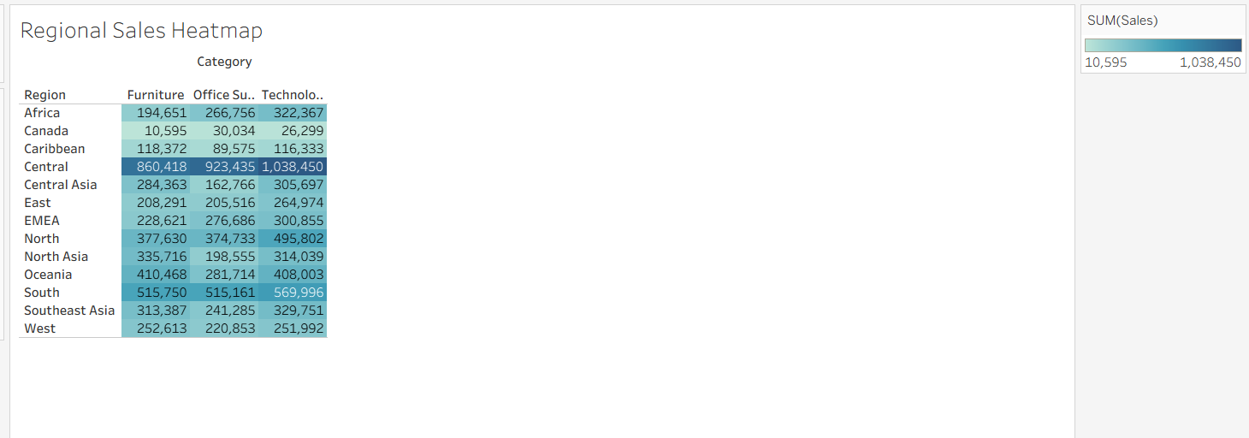

Geographical Map:
Objective: Visualize total sales by country.
Set Country as the geographical field.
Use Sales to define size and color gradients.
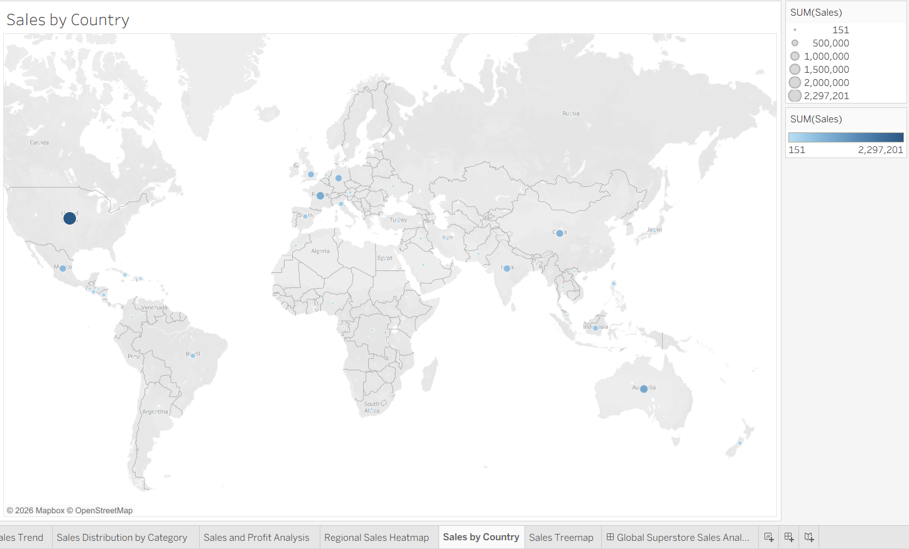

Tree Map:
Objective: Display sales distribution by category and sub-category. Use Category and Sub-Category as dimensions, and Sales as the measure. Customization and Interactivity:
Add filters to explore data subsets interactively (e.g., by year, region, or category). Include annotations, labels, and formatting for clarity.

Dashboard Creation:
Combine all charts into a single dashboard to present a cohesive story. Add interactive filters and tooltips for dynamic exploration.
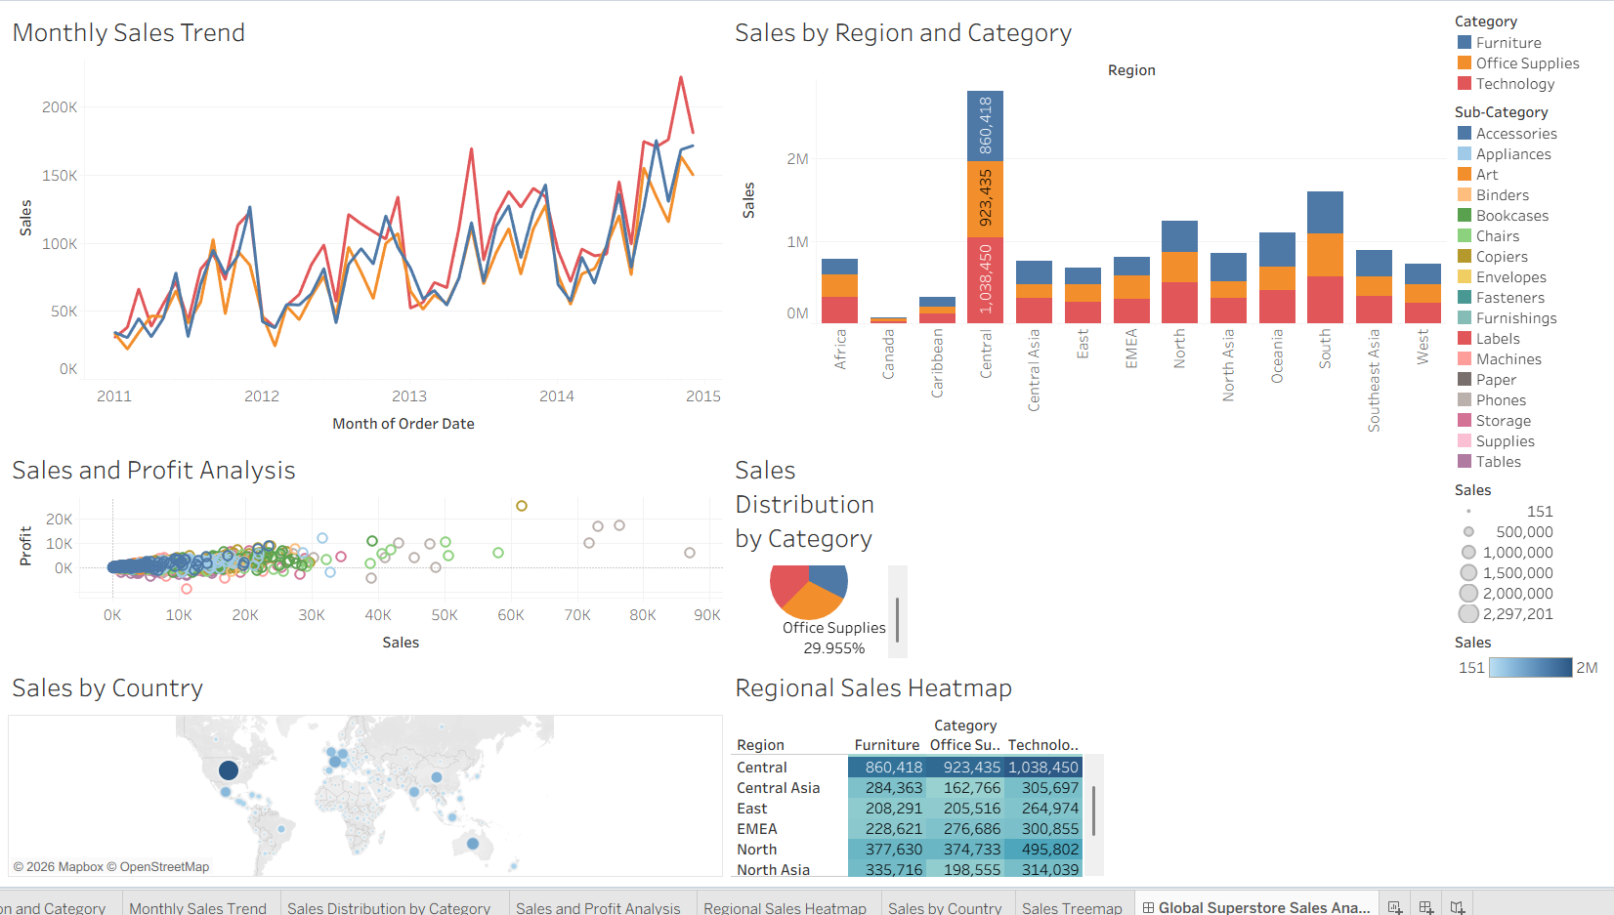

Experiment Dataset:
Global Superstore Sales Dataset
Source: https://www.kaggle.com/datasets/apoorvaappz/global-super-store-dataset

Fields Used:
Order Date Region Category
Sub-Category Sales
Profit
Country

POST-LAB QUESTIONS (PROVIDE BRIEF ANSWERS TO THE FOLLOWING QUESTIONS)

Bar Chart:
What regions had the highest and lowest total sales?

The Central region had the highest total sales, while the Africa region had the lowest total sales among the major regions in the dataset.
How does the performance of categories vary across regions?
Technology generally performs strongly across most regions, while Furniture and Office Supplies show varying performance. The best-performing category differs depending on the region, indicating regional differences in customer demand.

Line Chart:
Identify the month with peak sales.
The month with peak sales can be identified from the highest point on the monthly sales trend line. In the Global Superstore dataset, sales typically peak during the November–December period.
Which category shows consistent growth in sales over time?
Technology generally shows the most consistent growth in sales over time, although fluctuations may occur in individual months.

Pie Chart:
Which category contributes the most to overall sales?
Technology contributes the most to overall sales in the Global Superstore dataset.
Are there any categories with negligible sales contributions?
No category has a negligible contribution. However, the category with the smallest percentage of total sales contributes significantly less than the leading category.

Scatter Plot:
Is there a noticeable correlation between profit and sales?
Yes, there is generally a positive relationship between sales and profit. However, some transactions have high sales but low or negative profit because of factors such as discounts and shipping costs.
Heatmap:
Which region-category combination has the highest sales?
The region-category combination with the darkest or most intense color in the heatmap represents the highest sales. In the Global Superstore dataset, Technology in the Central region is often among the strongest combinations.
Identify any regions with poor sales performance across all categories.
The Africa region generally shows lower sales across multiple categories compared with major markets such as Central, East, and Oceania.

Geographical Map:
Which country has the highest total sales?
The United States generally has the highest total sales in the Global Superstore dataset.
Are there regions with minimal or no sales?
Yes. Some countries and regions have very low sales because of limited transactions. Countries with no records in the dataset will not appear on the map.
Tree Map:
Which sub-category dominates the sales in each category?
The dominant sub-category can be identified by the largest rectangle within each category. Typically:
- Furniture → Chairs
- Office Supplies → Storage or Binders
- Technology → Phones

Are there any sub-categories with unexpectedly low sales?
Yes. Smaller rectangles in the treemap represent sub-categories with relatively low sales. These may include specialized products such as Labels, Fasteners, or Envelopes, depending on the applied filters.
Dashboard:
What insights can you derive when combining all visualizations?
The dashboard provides a comprehensive view of the business by showing sales trends over time, regional and category performance, profitability, geographical distribution, and sub-category contributions. Combining these visualizations helps identify high-performing markets, profitable categories, sales trends, and areas requiring improvement.
How do filters enhance the utility of the dashboard?
Filters allow users to interactively analyze specific subsets of data based on parameters such as year, region, category, segment, and market. This makes the dashboard more flexible and helps users perform detailed, focused analysis without creating separate charts for every data subset.

Github Repo - > https://github.com/Pavann-07/24ADC001---24BAD085.git

ASSESSMENT

Description | Max Marks | Marks Awarded
Pre Lab Exercise | 5
In Lab Exercise | 10
Post Lab Exercise | 5
Viva | 10
Total | 30
Faculty Signature

